SECTION 1: Identity Statement
Headline:
Builder, father, operator and…
Big Statement:
YOUR LEGACY'S BIGGEST DEFENDER.
Subheadline:
You have what it takes. Stop transferring money and start transferring the capability that built it.

SECTION 2: Tribal Selection
Headline:
For the builders...
Subheadline:
...who KNOW they're building something bigger than themselves.
Supporting Copy (optional):
You didn't pour concrete at sunrise, sacrifice weekends, and bet everything on your vision just to watch it crumble in your kids' hands. You're building a legacy—not just a business.

┌─────────────────────────────────────────┐
│ Small eyebrow text (light blue): │
│ Builder, father, operator and… │
│ │
│ MASSIVE HEADLINE (white, bold): │
│ YOUR LEGACY'S │
│ BIGGEST DEFENDER. │
│ │
│ Subheadline (lighter, readable): │
│ You have what it takes. Stop │
│ transferring money and start │
│ transferring the capability that │
│ built it. │
│ │
│ [Image: You on jobsite or with family] │
└─────────────────────────────────────────┘
```

### **Section 2 Structure:**
```
┌─────────────────────────────────────────┐
│ Large headline (centered): │
│ For the builders... │
│ │
│ Bigger text (centered, bold): │
│ ...who KNOW they're building │
│ something bigger than themselves. │
│ │
│ [Photo: Construction workers/ │
│ multi-generational family image] │
│ │
│ Body copy (centered): │
│ You didn't pour concrete at sunrise... │
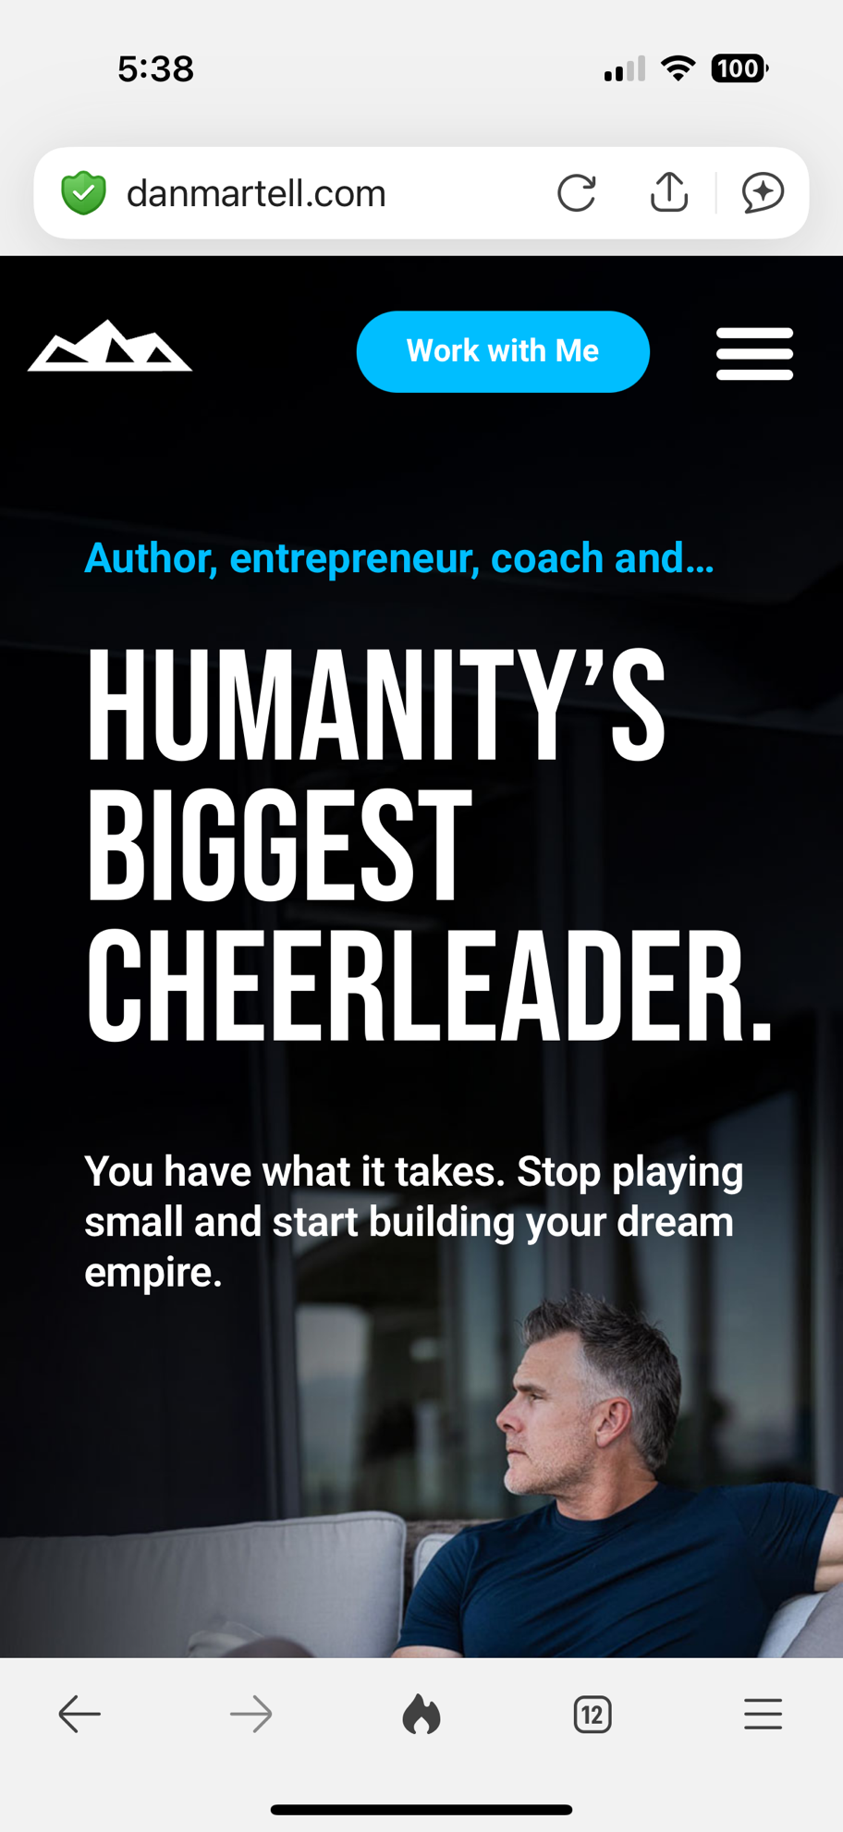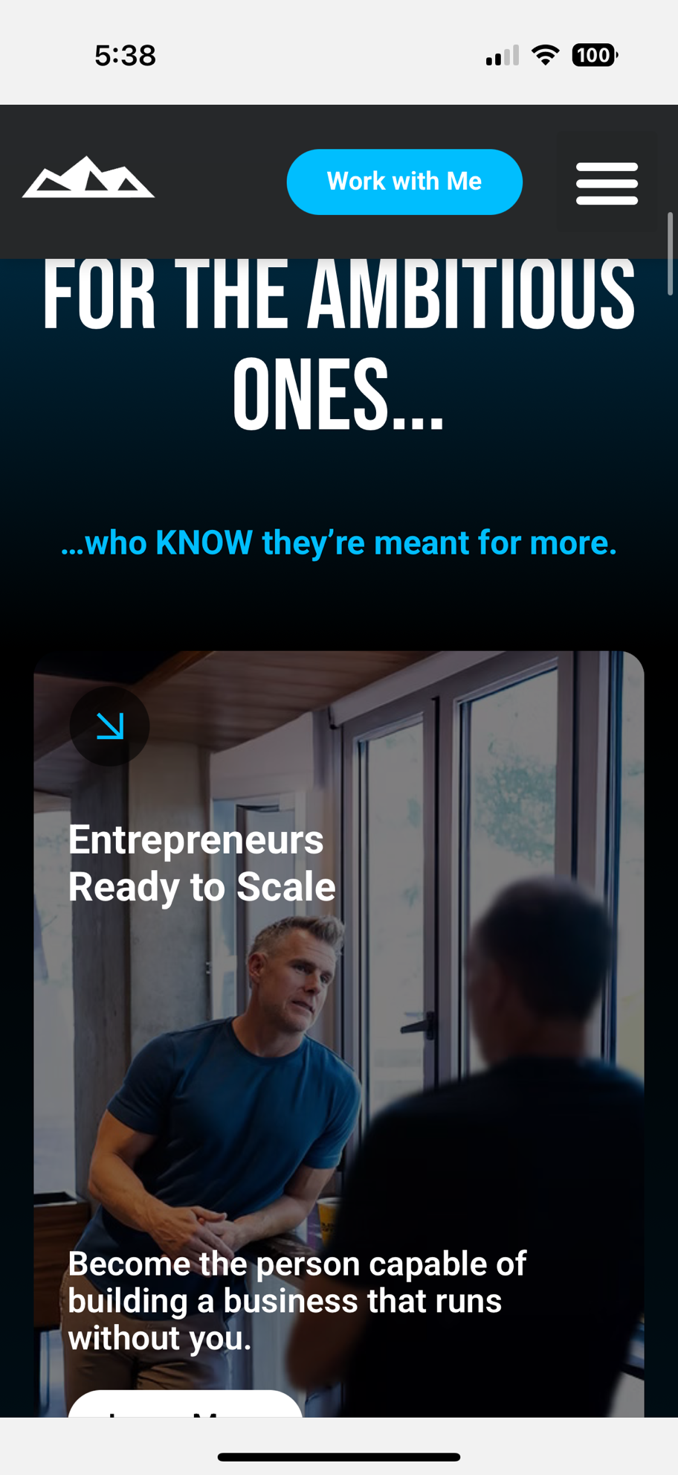

Tone Checklist (Matches Dan's Energy):
✅ Confident, not tentative ("You have what it takes" vs "I think you might need this")
✅ Tribal language ("For the builders" vs "For anyone interested")
✅ Identity reinforcement ("Your legacy's biggest defender" vs generic claims)
✅ Emotional activation ("Stop playing small" energy without saying those exact words)
✅ Clear villain (The 97% failure pattern, not your kids or you)

